Dear Landlord/managing agent/housing provider,

Below is some sample text for you to copy or adapt into communications with your residents when the wrong items have been put in the recycling bin/s.

The recycling could not be collected from the recycling bin/s for your block because:
- It contained items that cannot be recycled, e.g. rubbish, nappies, clothes, wood, household objects or;
- The recycling was contained in black bin bags. Any recycling in black bin bags cannot be recycled.

When it comes to recycling we all make mistakes sometimes. However, if the wrong items are put in the recycling it cannot be collected by the council’s recycling team.

Why is it a problem?
- If the recycling crews collect items that cannot be recycled, then the whole vehicle load of recycling may not be accepted at the recycling facility and will be treated as rubbish.
- When rubbish becomes mixed up with recycling it can be dangerous to recycling workers and damage equipment at the recycling sorting facility.
- If the recycling has the wrong items in it then the collection will be delayed, and a cost charged for the removal of the rubbish.

The recycling bin is not collected until either the incorrect items are removed, another contractor clears the recycling bin, or a fee is paid to the council for a refuse vehicle to clear the waste.

Dry mixed recycling
No thank you
Never put these in the recycling bin:

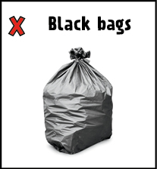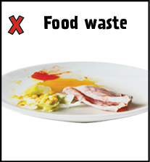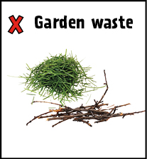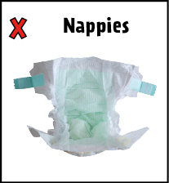

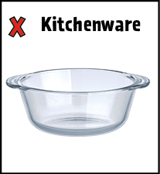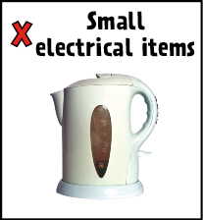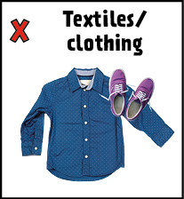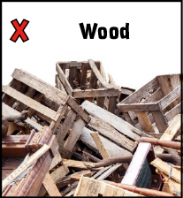

Yes please recycle these:
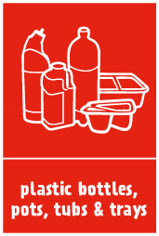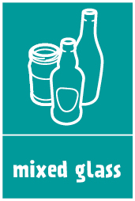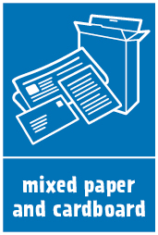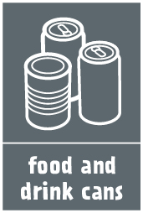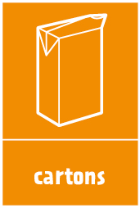

Visit www.islington.gov.uk/recycling if you want to find out more about recycling.

If you want to sign up to be a recycling champion and help spread information about how to recycle and reduce waste please email recyclingchampions@islington.gov.uk

