Street by street access in Canonbury East people-friendly streets
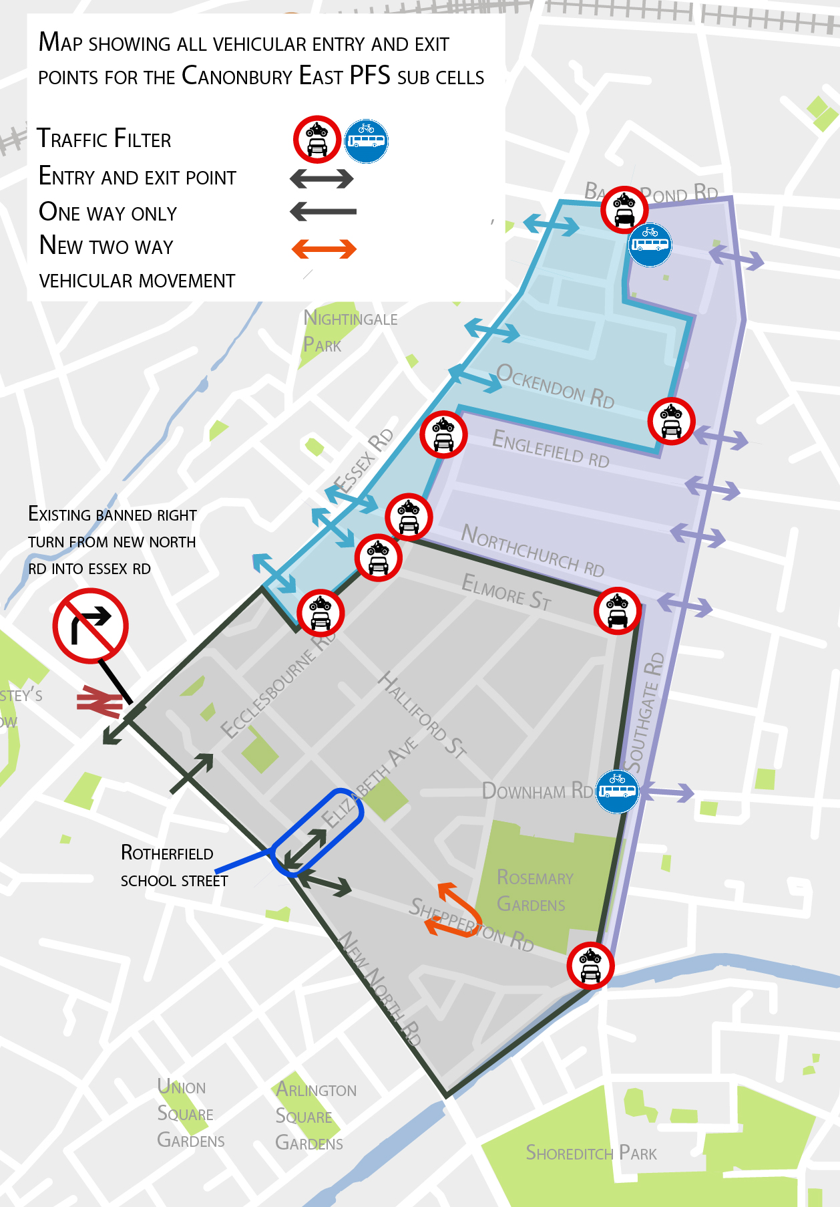
School Street at Elizabeth Avenue (between New North Road and Rotherfield Street)
8:30-9:15am and 3:15-4pm Monday to Friday – term times only.
From Monday 14 September 2020
The right turn ban from Balls Pond Road into Southgate Road is removed. Cars travelling east are able to turn right into Southgate Road from Balls Pond Road.
West sub cell (light blue on map)
Local Street | To main road | From main road
 | To NEW NORTH ROAD | From NEW NORTH ROAD
Halliford Street west of filter Elmore Street west of filter Northchurch Road west of filter Englefield Road west of filter  Ockendon Road west of filter  Mitchison Road  Wakeham Street  Dove Road east of filter | Essex Road | Baring Street ➔ Southgate Road ➔ Balls Pond Road ➔ Essex Road
Halliford Street west of filter  Elmore Street west of filter Northchurch Road west of filter  Englefield Road west of filter  Ockendon Road west of filter  Mitchison Road  Wakeham Street  Dove Road west of filter | To SOUTHGATE ROAD | From SOUTHGATE ROAD
 | Option 1. Essex Road ➔ Balls Pond Road  Option 2. Essex Road ➔ New North Road ➔ Baring Street | Balls Pond Road ➔ Essex Road

Eastern sub cell (purple on map)
Local Street | To main road | From main road
 | To NEW NORTH ROAD | From NEW NORTH ROAD
Northchurch Road east of filter  Oakley Road east of filter  Englefield Road east of filter  Ockendon Road east of filter  Dove Road east of filter | Southgate Road ➔ Baring Street | Baring Street ➔ Southgate Road
Northchurch Road east of filter Oakley Road east of filter Englefield Road east of filter Ockendon Road east of filter  Dove Road east of filter | To ESSEX ROAD | From ESSEX ROAD
 | Option 1. Southgate Road ➔ Balls Pond Road  Option 2. Southgate Road ➔Baring Street ➔ New North Road ➔ Southern end of Essex Road (between New North Road and Upper Street) | Option 1. New North Road ➔ Baring Street ➔ Southgate Road  Option 2. Balls Pond Road ➔ Southgate Road

Southern sub cell (grey on map)
Local Street | To main road | From main road
 | To NEW NORTH ROAD | From NEW NORTH ROAD
Shepperton Road east of Sherborne Street | Shepperton Road | Shepperton Road
Downham Road west of filter | To NEW NORTH ROAD | From NEW NORTH ROAD
 | Option 1. Halliford Street ➔ Elizabeth Avenue (outside of school street hours)  Option 2. Halliford Street ➔ Elizabeth Avenue ➔ Rotherfield Street ➔ Shepperton Road | Option 1. Elizabeth Avenue (outside School Street hours) ➔ Halliford Street  Option 2 Shepperton Road ➔ Sherborne Street
 | To SOUTHGATE ROAD | From SOUTHGATE ROAD
 | Option 1. Halliford Street ➔ Elizabeth Avenue (outside School Street hours) ➔ New North Road ➔Baring Street  Option 2. Halliford Street ➔ Elizabeth Avenue ➔Rotherfield Street ➔ Shepperton Road ➔ New North Road ➔ Baring Street | Option 1. Baring Street ➔ New North Road ➔ Elizabeth Avenue (outside School Street hours) and Halliford Street  Option 2. Baring Street ➔ New North Road ➔ Shepperton Road ➔ Sherborne Street
Elmore Street west of filter | To SOUTHGATE ROAD | From SOUTHGATE ROAD
 | Essex Road ➔ New North Road ➔ Baring Street | Balls Pond Road ➔ Essex Road
 |  | From NEW NORTH ROAD
 |  | Baring Street ➔ Southgate Road ➔ Balls Pond Road – Essex Road
Elmore Street east of filter | To ESSEX ROAD (between New North Road and Balls Pond Road) | From ESSEX ROAD (between New North Road and Balls Pond Road)
 | Option 1. Ecclesbourne Road ➔ Elizabeth Avenue (outside of School Street hours) ➔ New North Road ➔ Baring Street ➔ Southgate Road ➔ Balls Pond Road  Option 2. Ecclesbourne Road, Morton Road or Elizabeth Avenue ➔ Rotherfield Street ➔ Shepperton Road ➔ New North Road ➔ Baring Street ➔ Southgate Road ➔ Balls Pond Road | New North Road ➔ Ecclesbourne Road
Elmore Street east of filter | To ESSEX ROAD (between Upper Street and New North Road) | To ESSEX ROAD (between Upper Street and New North Road)
 | Option 1. Ecclesbourne Road ➔ Elizabeth Avenue (outside of School Street hours) ➔ New North Road  Option 2. Ecclesbourne Road, Morton Road or Elizabeth Avenue ➔ Rotherfield Street ➔ Shepperton Road ➔ New North Road | New North Road ➔ Ecclesbourne Road
Halliford Street west of filter | To SOUTHGATE ROAD | From SOUTHGATE ROAD
 | Option 1. Essex Road ➔New North Road ➔ Baring Street  Option 2. Essex Road ➔ Balls Pond Road | Balls Pond Road ➔ Essex Road
 | To NEW NORTH ROAD | From NEW NORTH ROAD
 | Essex Road ➔ New North Road | Baring Street ➔Southgate Road ➔ Balls Pond Road ➔ Essex Road
Halliford Street east of filter | To ESSEX ROAD (between New North Road and Balls Pond Road) | From ESSEX ROAD (between New North Road and Balls Pond Road)
 | Option 1. Elizabeth Avenue (outside School Street hours) ➔ New North Road ➔Baring Street ➔ Southgate Road ➔ Balls Pond Road  Option 2. Morton Road or Elizabeth Avenue ➔ Rotherfield Street ➔ Shepperton Road ➔ New North Road ➔ Baring Street ➔ Southgate Road ➔ Balls Pond Road | Option 1. New North Road ➔ Ecclesbourne Road  Option 2. Balls Pond Road ➔ Southgate Road ➔ Baring Street ➔New North Road
Halliford Street east of filter | To ESSEX ROAD (between Upper Street and New North Road) | From ESSEX ROAD (between Upper Street and New North Road)
 | Option 1. Elizabeth Avenue (outside School Street hours) ➔ New North Road  Option 2. Morton Road or Elizabeth Avenue ➔ Rotherfield Street ➔ Shepperton Road ➔ New North Road | New North Road ➔ Ecclesbourne Road

